**Smart Milk Spoilage Experiment Analysis and Result**

1. **Analysis**

In this experiment, we monitored two milk samples over a specified period—one stored under refrigeration and another kept at room temperature—to observe how temperature conditions affect the rate and extent of spoilage.

1. **Data Collected:**

* Timestamped Temperature Readings:  
  For both the refrigerated and unrefrigerated milk, temperatures were recorded over time. The refrigerated sample maintained a consistent temperature range (approximately 37–39°F), while the unrefrigerated sample remained around room temperature (approximately 67–68°F).
* Smell Observations (Qualitative Spoilage Indicator):  
  Both milk samples were assessed at regular intervals by smell. Descriptors included “Fresh,” “Slightly Sour,” “Noticeably Sour,” and “Sour/Spoiled.” These categories were converted to numeric scores to quantitatively track spoilage progression.

1. **Methodology:**

* The refrigerated milk was stored in a standard refrigerator with low-temperature conditions.
* The unrefrigerated milk was left at ambient room temperature conditions, exposing it to a much warmer environment favorable to faster bacterial growth.
* Smell tests were conducted twice daily to track sensory changes.
* Camera images and temperature measurement were taken periodically (every five minutes) for the unrefrigerated milk.
* Data was logged, processed, and plotted over time to identify trends and key spoilage onset points.

1. **Graphs for Analysis:**
2. Unrefrigerated Milk Temperature Over Time:  
   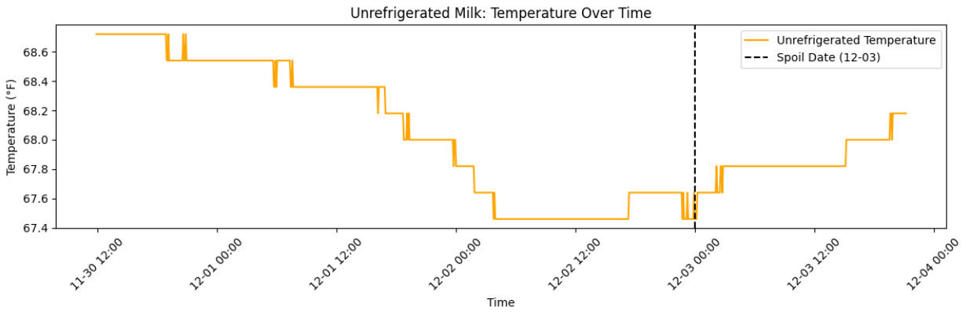
3. Refrigerated Milk Temperature Over Time: Displays the stability and consistently low temperature in the refrigerator environment.  
   A graph showing the temperature of milk

   Description automatically generated
4. Unrefrigerated Milk Spoilage Progression Over Time (Smell Score): Tracks the smell from “Fresh” to “Sour/Spoiled” and highlights the point on December 3rd when the milk clearly reached a spoiled state.  
   A graph with a red line

   Description automatically generated
5. Refrigerated Milk Spoilage Progression Over Time (Smell Score): Illustrates how the refrigerated sample remained largely fresh or only minimally deteriorated over the same period.

1. **Results**
2. Unrefrigerated Milk:
   * The data shows that milk stored at room temperature began to exhibit signs of spoilage within approximately one to two days, transitioning from “Fresh” to “Slightly Sour” and then becoming “Noticeably Sour.”
   * By December 3rd, the unrefrigerated milk had reached a clearly “Sour/Spoiled” state, as confirmed by both smell tests and visual evidence (images showing curdling or discoloration).
   * The relatively high temperature (~68°F) accelerated bacterial growth and fermentation processes which led to rapid spoiling process.
3. Refrigerated Milk:
   * The refrigerated milk’s temperature remained around 38°F, significantly slowing bacterial growth.
   * Over the same time period, the refrigerated sample remained “Fresh” for most of the observation window, with only a very slight sourness developing after six days.
   * This difference in the spoilage rate underscores the importance of proper refrigeration.

Key Observations:

* Higher storage temperatures strongly link with faster spoilage.
* Milk at proper refrigeration temperatures stays fresher for longer, delaying both sensory (smell-based) and visual signs of spoilage.
* The spoilage date (December 3rd) for the unrefrigerated milk provides a clear benchmark for how quickly milk can degrade without temperature control.

1. **Summary**

This experiment demonstrates the direct impact of temperature on milk spoilage. The unrefrigerated milk, maintained at approximately 68°F, transitioned from fresh to spoiled within three days which illustrates a rapid decline in quality. In contrast, the refrigerated milk remained fresh much longer under stable, cold conditions (around 38°F), showing significantly delayed spoilage onset.

These findings support standard food safety guidelines which highlight maintaining proper refrigeration is vital to extending the shelf life of dairy products. The combination of quantitative (temperature logs, smell scores) and qualitative (visual inspection, descriptive smell tests) approaches offers a comprehensive understanding of spoilage dynamics in different environmental conditions.